Motivation :Help the business recover more money, faster, with less effort.

- ML
- Backend
- Frontend

- ML
Question to ask?
Which overdue cases should we chase first, and with which DCA

This is a binary classification + ranking problem.
- Target Variable
  - recovered → 1 if recovered, 0 if not
- Model Output
  - recovery_probability ∈ [0,1]
From this we derive:
- Risk Score = 1 - recovery_probability
- Priority = High / Medium / Low

Data generation: generate altleast 10,000 rows

Raw Data Schema (Must Make Sense)
Feature | Meaning
case_id | Unique case
amount_due | Outstanding amount
days_overdue | Days since due
customer_type | Retail / SME / Corporate
region | North / South / West / East
past_defaults | Number of past defaults
credit_score | 300–900
dca_id | Assigned agency
dca_success_rate | Historical recovery %
contact_attempts | Calls made
last_contact_days | Days since last contact
recovered | TARGET (0/1)

🔧 How You Generate It
Use probabilistic logic, not random nonsense.
Example logic:
- Higher days_overdue → lower recovery chance
- Higher credit_score → higher recovery
- Higher dca_success_rate → higher recovery
This shows domain understanding.

Feature Engineering

Raw features → Business features.

🔹 Derived Features
Feature | Why
overdue_bucket | Non-linear effect
log_amount_due | Stabilize variance
dca_effectiveness | Agency skill
contact_intensity | Effort vs outcome
risk_exposure | amount × overdue
This is more important than model choice.
Model Choice (Don’t Be Stupid Here)

Start Simple → Explainable
- Logistic Regression
  - Baseline
  - Interpretable
- Random Forest / XGBoost
  - Capture non-linear patterns
  - Handles mixed data well
Training Pipeline
Steps
- Train / Validation split
- Encode categorical variables
- Scale numeric features (if needed)
- Train model
- Evaluate

Metrics (Business-Friendly)
- AUC-ROC → ranking quality
- Precision @ High Risk → fewer wasted calls
- Recall @ High Priority → don’t miss recoverable cases

ML Output Schema (Non-Negotiable)
{
"case_id": "C10231",
"recovery_probability": 0.78,
"risk_score": 0.22,
"priority": "LOW"
}

Priority Rules (Simple & Transparent)
Probability | Priority
> 0.7 | Low Risk
0.4 – 0.7 | Medium
< 0.4 | High Risk
This logic must be documented.
You don’t implement this, you explain it:
- Monitor prediction vs actual recovery
- Retrain monthly
- Flag DCA drift if performance drops
This scores architectural points.

ML Deliverables
/ml
├── data_generation.py
├── feature_engineering.py
├── train.py
├── evaluate.py
├── predict.py
├── model.pkl
└── README.md

Frontend goal :Turn ML outputs + backend data into clear actions for humans.

User Roles & Views (CRITICAL)

🔹 Admin (Enterprise / Ops)
- Overall performance
- Which DCA is working
- Where money is stuck

🔹 DCA Agent
- Assigned cases only
- Clear priority order
- Simple status update
Frontend must change by role.

3️⃣ Pages to Build (Minimal but Strong)

1️⃣ Login Page
- Email + password
- JWT stored in localStorage
- Role fetched after login

2️⃣ Admin Dashboard (MOST IMPORTANT)
KPIs at the top
- Total Cases
- Recovered %
- High-Risk Cases
- Avg Days Overdue
Charts
- Recovery Rate by DCA (Bar)
- Risk Distribution (Pie)
- Cases vs Days Overdue (Line)
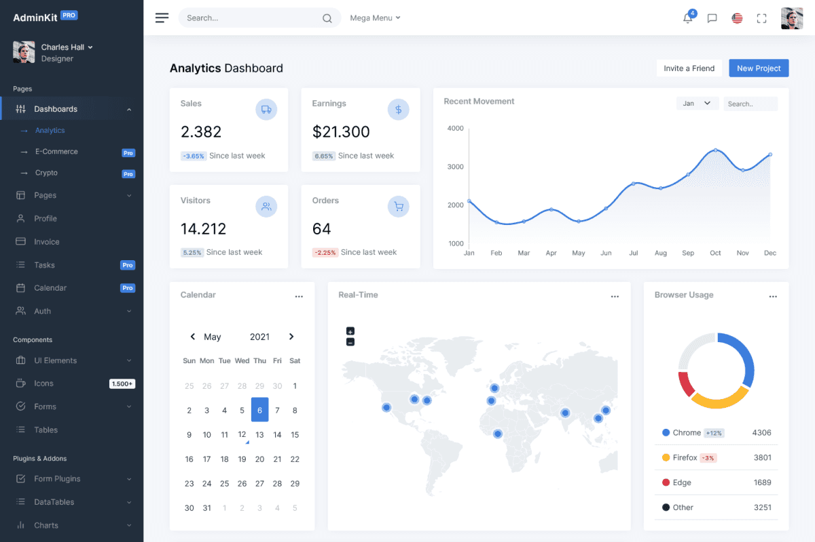
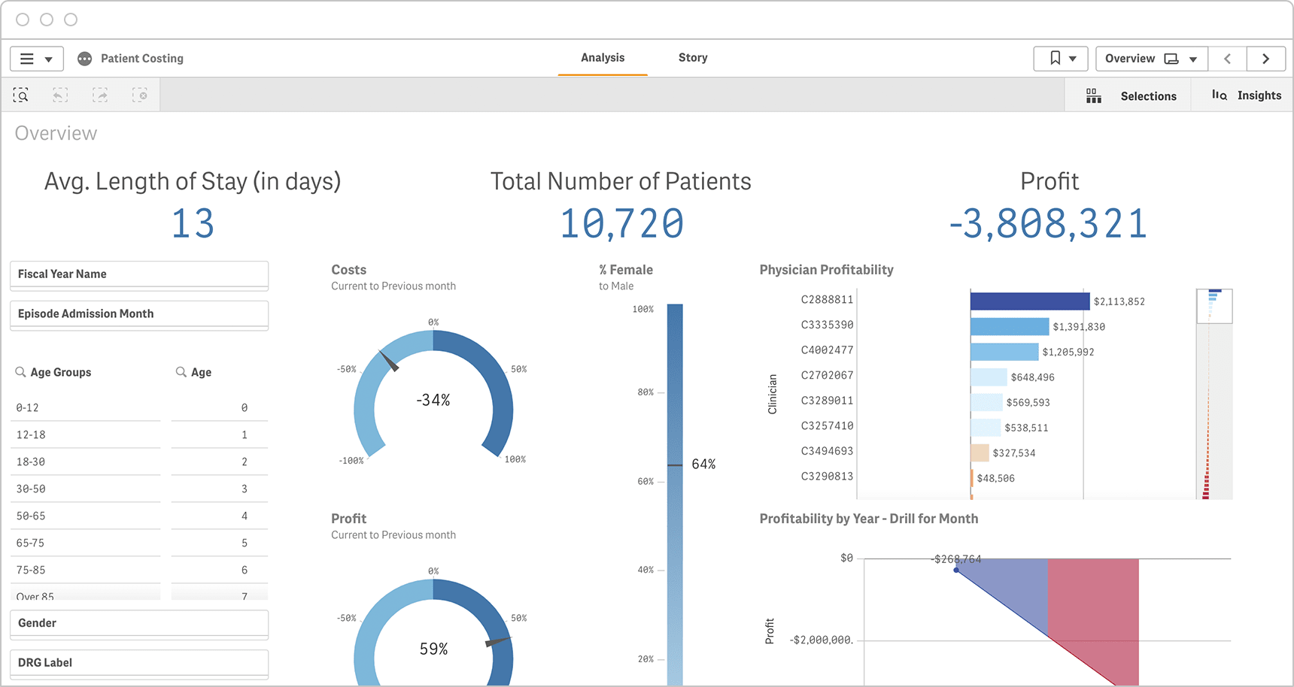
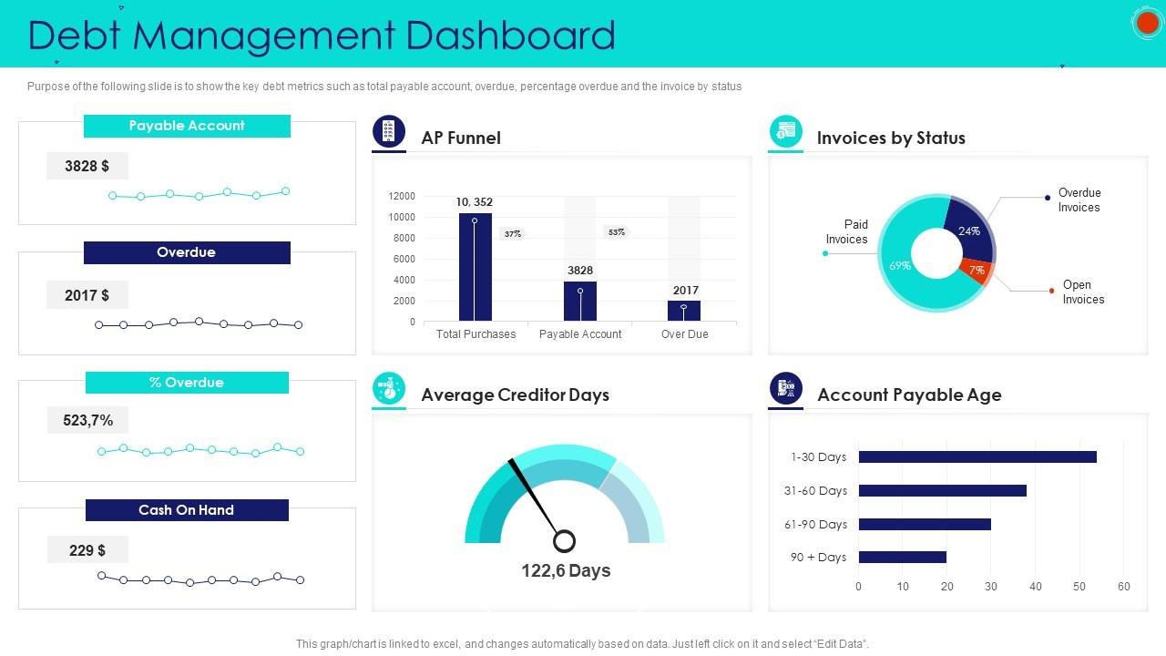

3️⃣ Case Management Table
This is where ML shines.
Columns
- Case ID
- Amount Due
- Days Overdue
- Risk Score (color-coded)
- Priority (🔥🟡🟢)
- Assigned DCA
- Status
Filters
- Priority
- DCA
- Overdue Days
Sorting
- Default → Highest Risk first
This makes ML visible.
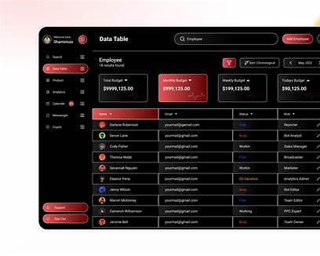
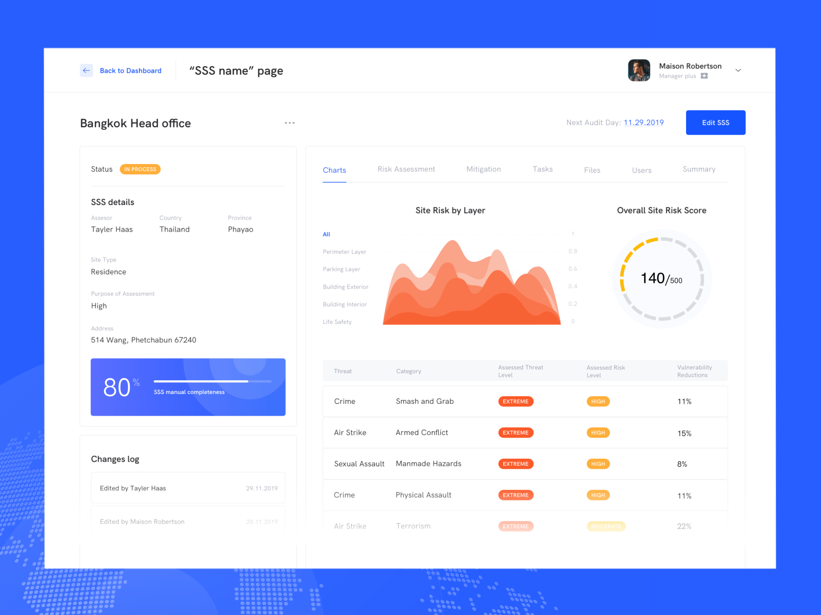
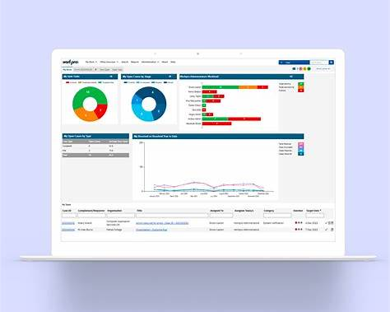

4️⃣ DCA Agent View
Simple. No charts.
- Assigned cases list
- Priority highlighted
- Action buttons:
  - Contacted
  - Promised to Pay
  - Recovered
  - Failed
Agent UX must be fast.
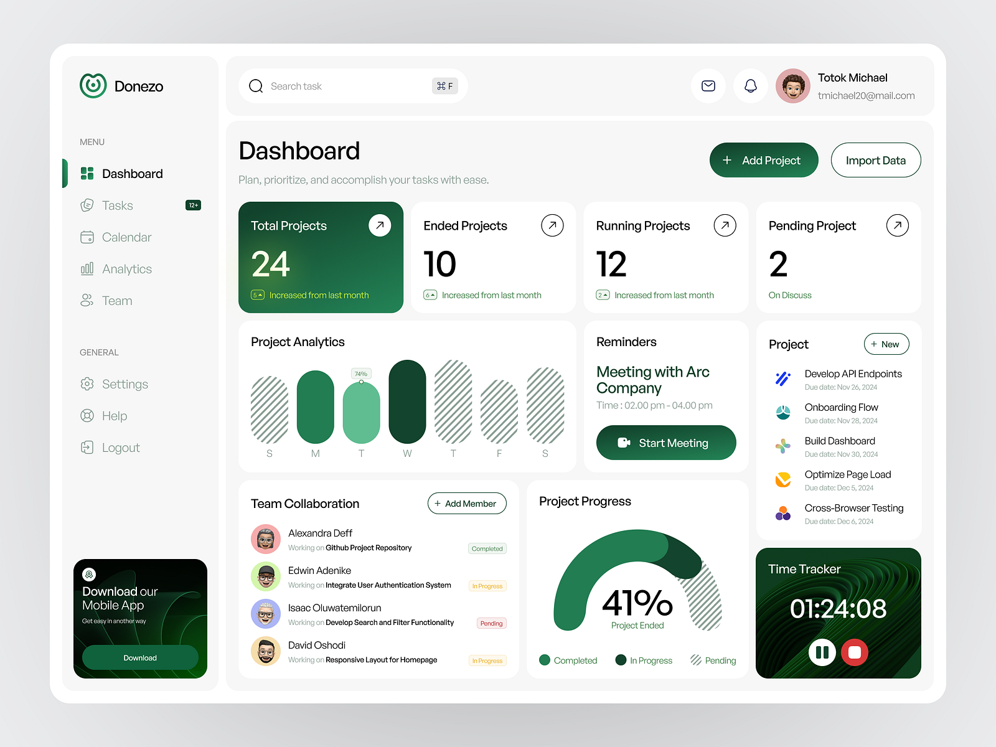
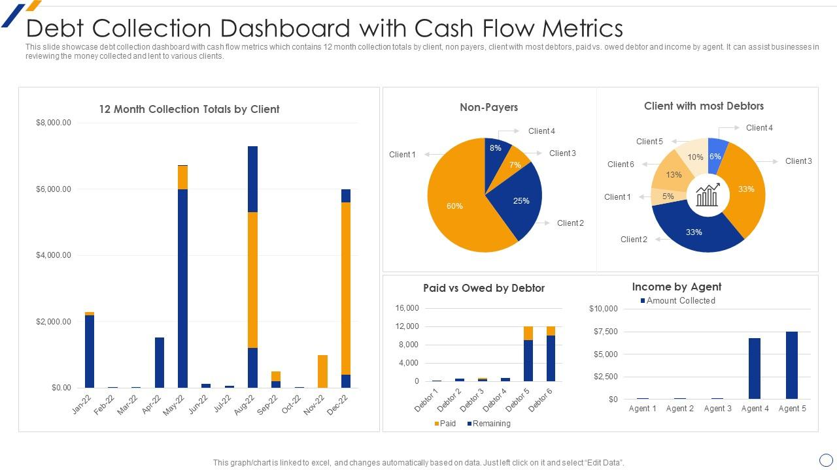

4️⃣ How ML Output Is Used in UI
ML gives:
{
"risk_score": 0.82,
"priority": "HIGH"
}

UI Mapping
Priority | Color
HIGH | 🔴 Red
MEDIUM | 🟡 Yellow
LOW | 🟢 Green
Risk Score:
- Progress bar
- Tooltip explanation
This screams AI-powered without saying it.

5️⃣ Component Structure (Clean React)
/src
├── pages/
│ ├── Login.jsx
│ ├── AdminDashboard.jsx
│ ├── CaseTable.jsx
│ └── DcaDashboard.jsx
├── components/
│ ├── KPIcard.jsx
│ ├── RiskBadge.jsx
│ ├── CaseRow.jsx
│ └── Charts.jsx
├── services/
│ └── api.js
└── context/
└── AuthContext.jsx

6️⃣ API Calls (Frontend Contracts)
Frontend only needs 5–6 endpoints.
GET /cases
GET /cases?priority=HIGH
POST /cases/status
GET /analytics/summary
POST /auth/login

No frontend logic should guess ML. Backend handles that.
Backend goal : Enforce business rules
Serve ML intelligence
Maintain auditability
Expose clean APIs to frontend

1️⃣ Backend Responsibilities (Non-Negotiable)
Backend MUST handle:
- Authentication & roles
- Case lifecycle
- ML score integration
- Analytics aggregation
- Data consistency
Frontend should be dumb.
ML should be isolated.

Core Data Models (MongoDB)

🔹 User Collection
{
"_id": "u1",
"email": "admin@corp.com",
"role": "ADMIN" | "DCA",
"dca_id": "dca_01"
}

🔹 DCA Collection
{
"dca_id": "dca_01",
"name": "Alpha Collections",
"success_rate": 0.68
}

🔹 Case Collection (MOST IMPORTANT)
{
"case_id": "C10021",
"amount_due": 45000,
"days_overdue": 120,
"customer_type": "SME",
"region": "West",
"dca_id": "dca_01",

"risk_score": 0.82,
"priority": "HIGH",

"status": "NEW",
"last_updated": "2026-01-05"
}

🔹 Audit Log
{
"case_id": "C10021",
"action": "STATUS_UPDATED",
"old_value": "IN_PROGRESS",
"new_value": "RECOVERED",
"timestamp": "..."
}

This screams enterprise-grade.

Authentication & Roles

Roles
Role | Access
ADMIN | All cases, analytics
DCA | Assigned cases only
JWT payload:
{
"user_id": "u1",
"role": "ADMIN"
}

Middleware checks role on every request.

ML Integration (Critical)
Backend calls ML once per case.

Flow
- Case uploaded
- Backend sends features to ML
- ML returns probability
- Backend:
  - Computes priority
  - Stores result
Backend owns the rule logic, not ML.

API Endpoints (Minimal & Powerful)

Auth
POST /auth/login

Case Management
POST /cases/upload
GET /cases
GET /cases/{id}
PATCH /cases/{id}/status

POST /ml/score

Analytics
GET /analytics/summary
GET /analytics/dca-performance

Business Rules (Backend Only)
Example:
if recovery_prob < 0.4:
priority = "HIGH"
elif recovery_prob < 0.7:
priority = "MEDIUM"
else:
priority = "LOW"

Frontend never decides priority.

Folder Structure (Professional)
/backend
├── main.py
├── database.py
├── auth/
├── routes/
│ ├── cases.py
│ ├── analytics.py
│ └── ml.py
├── models/
├── services/
│ └── ml_service.py
└── utils/
Analytics Logic (Backend Aggregation)
Backend computes:
- Recovery %
- Avg overdue days
- DCA ranking
- High-risk case count
Mongo aggregation pipelines → frontend just displays.

